1:1 Customer Engagement for Delivery Architects

4 phases of Pega Express

Discover

Adopt

Prepare

Build

Pega Platform allows you to define customer Micro Journey and create tailored intuitive applications to deliver business outcomes quickly.

Pega Unit is Pega Automated Tool to enable test teams quickly

PDC allows you to assess the health of the application and notify critical issues.

Frequently used terms in Pega Express

Minimum Lovable Product(MLP)

Journey

MicroJourney

Direct Capture Objectives9DCO)

DevOps

MLP is a cycle delivering the requirements within a period of time and is a building block for an organization.

Journey- it is the interaction between customer and an organization as customer defines specific goals

MicroJourney- it will result in intermediate or final outcome. It will identify the teams and organize and optimize the processes needed to perform the work.

DCO9Direct Capture Objective)- it forms a continuous cycle of collaboration, iteration, and validation and deliver applications quicker.

DevOps- DevOps is a set of practices that bridge application development and operational behavior to reduce time to market.

Pega has pre-defined set of 1:1 customer engagements microjourneys based on years of experience across various implementations.

The microjourney Matrix captures all these pre defined microjourneys.

**For CDH implementations typically one Microjourney is addressed per MLP.**

**MLP Backlogs have been developed for most important microjourneys**

1. **Inbound**
2. **Outbound**
3. **Agent assisted using NBA Advisor**

**At tis point of time pega has industry specific microjourney matrices for the following industries**

1. **Communications**
2. **Financial services**
3. **United services healthcare**
4. **Insurance**
5. **Utilities**

**Optionated data models are**

1. **Financial services**
2. **Communications**
3. **Health care**
4. **Insurance**

**Templates have been provided by Pega on MarketPlace for the following use cases**

**Retail Banking and**

**NBA Advisor**

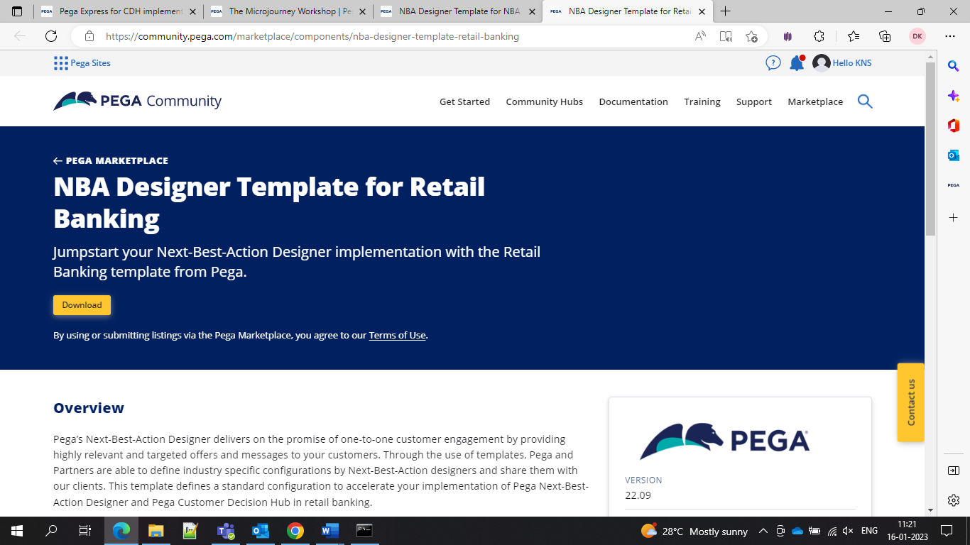

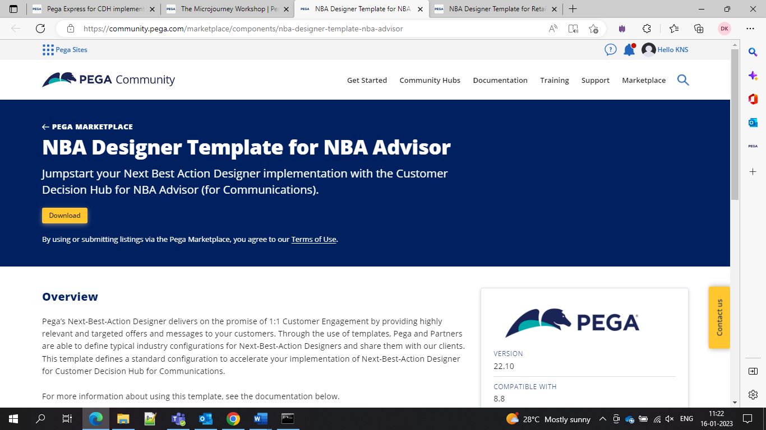

**When prioritizing microjourneys we should start with the inbound channels to obtain behavioural data**

**And the purpose of the microjourney matrix select a use case that will get value quickly, then accelerate and increase radiation.**

Data and interfaces

Microjourneys cases and strategies

Personas and channels

All these are core elements of a great application.

Pega provides an approach for the CDH through the Pre defined assests

Backlog will cover all the implementation- Discover, build, adapt, discover

During discover phase team tries to understand the desired outcomes, confirm the scope of the MLP.

During the Prepare phase your team sets the groundwork for the implementation by preparing the organization, infrastructure, and application.

In the build phase team starts to configure the CDH and NBA to setup logic, models, and reporting.

In the Adopt phase the transformation tasks required to allow the users and governance team to get the maximum value from CDH as usual(BAU).

An MLP is scoped alongside the channel and business objective and covers industry specific where applicable.

The first two MLP’s backlogs cover inbound digital and outbound. Planned backlogs go for retention, agent assisted, and Paid Media Manager.

Future MLP backlog development is prioritized based on Pega and Customer stratergic needs.

Application architecture looks inside and addresses the areas that are involved in the customer decision hub and it covers several items including the

NBA

Prediction Studio

Portals

1:1 Ops Manager

And also components like

Decision Strategies

Data Flows

Event Strategies

Content and treatments and simulations and reporting

Marketing- Interested in understanding how data can enable models to improve targeting and conversion rates for actions and offers.

Customer Experience- Interested in understanding how data can enable models and business rules to provide consistent omni-channel customer experiences and to drive voice of customer through the company.

Customer retention- Interested in understanding how data can enable models and business rules to improve retention Strategies and drive initiative to improve customer loyalty and to secure hih-CLV relationships.

Enterprise Architecture- interested in how the data models fit in and with the fast and slow data repository.

Data Science and Analytics- interested in how data models provide analytical predictors for use in predictive and adaptive models

Data Management- interested in how data model provide a standard structure to use for decisioning, and reporting and where the data comes from and is mastered.

**Eligibility- Used to determine whether a customer is allowed to have an action**

**Applicability-used to determine if an action is appropriate at this point of time**

**Suitability- Used to determine if an action is in the best interest of the customer.**

Here are some examples of the data models in different domains

